BIT Internship Practicals

Sneh Bhalgamiya

Program – 1 : Animated Popup Model Box

HTML :

<!DOCTYPE html>

<html lang="en">

<head>

<meta charset="UTF-8">

<meta http-equiv="X-UA-Compatible" content="IE=edge">

<meta name="viewport" content="width=device-width, initial-scale=1.0">

<title>Animated Popup Modal Box</title>

<link rel="stylesheet" href="style.css">

<!-- Boxicons CSS -->

<link href='https://unpkg.com/boxicons@2.1.1/css/boxicons.min.css' rel='stylesheet'>

</head>

<body>

<section>

<div class="profile">

<div class="profile-img">

<img src="profile.jpg" alt="">

</div>

<span class="name">Shubh Soni</span>

<span class="profession">Web & Web Designer</span>

<div id="hireBtn" class="button">

<i class="bx bxs-envelope"></i>

<button>Hire me</button>

</div>

</div>

<!-- popup box start -->

<div class="popup-outer">

<div class="popup-box">

<i id="close" class="bx bx-x close"></i>

<div class="profile-text">

<img src="profile.jpg" alt="">

<div class="text">

<span class="name">Shubh Soni</span>

<span class="profession">Web & Web Designer</span>

</div>

</div>

<form action="#">

<textarea spellcheck="false" placeholder="Enter your message"></textarea>

<div class="button">

<button id="close" class="cancel">Cancel</button>

<button class="send">Send</button>

</div>

</form>

</div>

</div>

</section>

<script>

const section = document.querySelector("section"),

hireBtn = section.querySelector("#hireBtn"),

closeBtn = section.querySelectorAll("#close"),

textArea = section.querySelector("textarea");

hireBtn.addEventListener("click", () => {

section.classList.add("show");

});

closeBtn.forEach(cBtn => {

cBtn.addEventListener("click", () => {

section.classList.remove("show");

textArea.value = "";

});

});

</script>

</body>

</html>

CSS :

/* Google Font Import - Poppins */

@import url("https://fonts.googleapis.com/css2?family=Poppins:wght@300;400;500;600;700&display=swap");

* {

margin: 0;

padding: 0;

box-sizing: border-box;

font-family: "Poppins", sans-serif;

}

body {

overflow: hidden;

}

section {

position: relative;

height: 100vh;

width: 100%;

display: flex;

align-items: center;

justify-content: center;

}

section .profile {

display: flex;

align-items: center;

flex-direction: column;

justify-content: center;

}

section.show .profile {

display: none;

}

section .profile .profile-img {

height: 150px;

width: 150px;

border-radius: 50%;

background: #4070f4;

padding: 2px;

margin-bottom: 20px;

}

.profile .profile-img img {

height: 100%;

width: 100%;

object-fit: cover;

border-radius: 50%;

border: 3px solid #fff;

}

.profile .name,

.profile .profession {

font-size: 22px;

font-weight: 500;

color: #333;

}

.profile .profession {

font-weight: 400;

margin-top: -6px;

}

.profile .button {

display: flex;

align-items: center;

padding: 12px 25px;

background: #4070f4;

margin-top: 20px;

border-radius: 6px;

cursor: pointer;

font-size: 24px;

transition: all 0.3s ease;

}

.profile .button:hover {

background: #275df1;

}

.profile .button i {

color: #fff;

font-size: 22px;

margin-right: 5px;

}

.profile .button button {

background: none;

outline: none;

border: none;

font-size: 20px;

color: #fff;

pointer-events: none;

}

section .popup-outer {

position: absolute;

display: flex;

align-items: center;

justify-content: center;

height: 100%;

width: 100%;

background: rgba(0, 0, 0, 0.4);

opacity: 0;

pointer-events: none;

box-shadow: 0 10px 15px rgba(0, 0, 0, 0.1);

transform: scale(1.2);

transition: all 0.3s ease-in-out;

}

section.show .popup-outer {

opacity: 1;

pointer-events: auto;

transform: scale(1);

}

section .popup-box {

position: relative;

padding: 30px;

max-width: 420px;

width: 100%;

background: #fff;

border-radius: 12px;

}

.popup-box .close {

position: absolute;

top: 16px;

right: 16px;

font-size: 30px;

color: #b4b4b4;

cursor: pointer;

transition: all 0.2s ease;

}

.popup-box .close:hover {

color: #333;

}

section .popup-box .profile-text {

display: flex;

align-items: center;

}

section .popup-box img {

height: 70px;

width: 70px;

object-fit: cover;

border-radius: 50%;

}

.profile-text .text {

display: flex;

flex-direction: column;

margin-left: 15px;

}

.profile-text .text .name {

font-size: 20px;

font-weight: 400;

}

.profile-text .text .profession {

font-size: 20px;

font-weight: 500;

}

section .popup-box textarea {

min-height: 200px;

width: 100%;

margin-top: 20px;

outline: none;

border: 1px solid #ddd;

padding: 12px;

border-radius: 6px;

resize: none;

font-size: 18px;

font-weight: 400;

background: #f3f3f3;

}

section .popup-box .button {

display: flex;

justify-content: flex-end;

margin-top: 15px;

}

.popup-box .button button {

outline: none;

border: none;

padding: 8px 14px;

border-radius: 6px;

background: #6f93f6;

margin-left: 12px;

color: #fff;

font-size: 14px;

cursor: pointer;

transition: all 0.3s ease;

}

.button button.cancel {

background: #f082ac;

}

.button button.cancel:hover {

background: #ec5f95;

}

.button button.send:hover {

background: #275df1;

}

JavaScript :

const section = document.querySelector("section"),

hireBtn = document.querySelector(".profile .button");

cancelBtn = document.querySelectorAll("#close");

hireBtn.addEventListener("click", ()=>{

section.classList.add("active");

})

cancelBtn.forEach(cBtn => {

cBtn.addEventListener("click", () =>{

section.classList.remove("active");

})

});

console.log(cancelBtn);

Output :

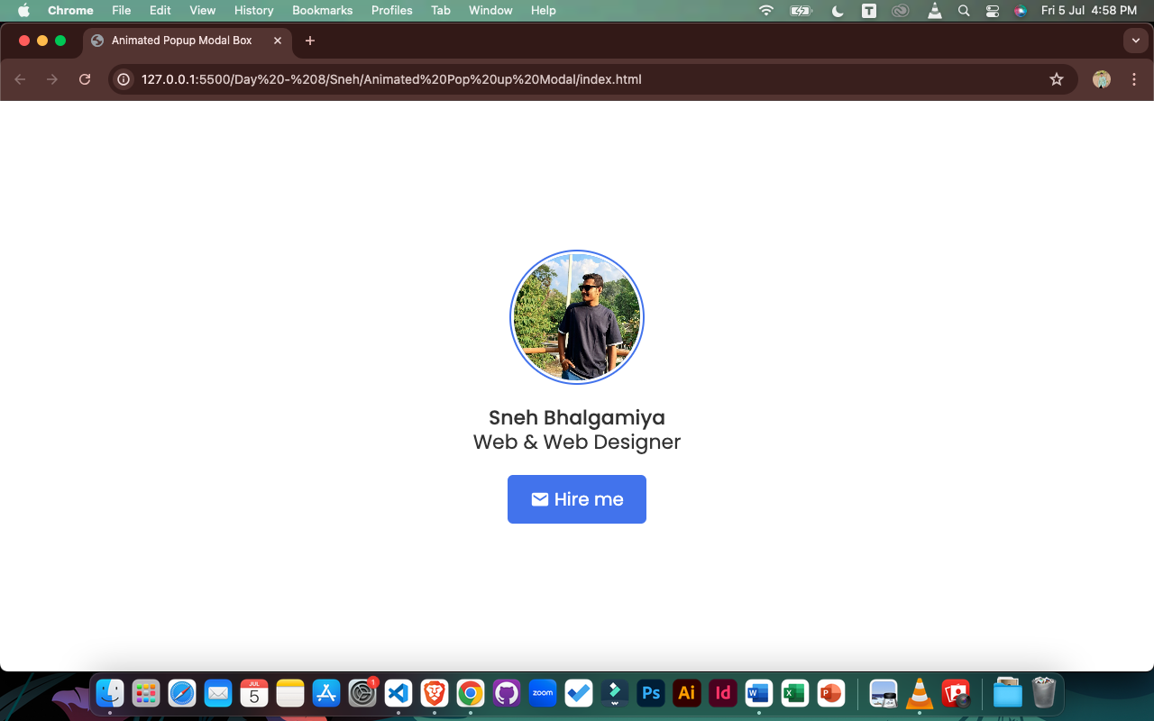

Program – 2 : Image Hover Animation

HTML :

<!DOCTYPE html>

<html lang="en" dir="ltr">

<head>

<meta charset="UTF-8" />

<title>Image Hover Animation HTML CSS</title>

<link rel="stylesheet" href="style.css" />

</head>

<body>

<div class="container">

<div class="icon-image">

<div class="icon">

<img src="profile.jpeg" alt="" />

</div>

<div class="hover-image one">

<div class="img">

<img src="profile.jpeg" alt="" />

</div>

<div class="content">

<div class="details">

<div class="name">David Marloo</div>

<div class="job">Designer || Developer</div>

</div>

</div>

</div>

</div>

<div class="icon-image">

<div class="icon">

<img src="profile.jpeg" alt="" />

</div>

<div class="hover-image one">

<div class="img">

<img src="profile.jpeg" alt="" />

</div>

<div class="content">

<div class="details">

<div class="name">Lilly Carls</div>

<div class="job">Blogger || Designer</div>

</div>

</div>

</div>

</div>

<div class="icon-image">

<div class="icon">

<img src="profile.jpeg" alt="" />

</div>

<div class="hover-image one">

<div class="img">

<img src="profile.jpeg" alt="" />

</div>

<div class="content">

<div class="details">

<div class="name">Stephen Bald</div>

<div class="job">Designer || Developer</div>

</div>

</div>

</div>

</div>

<div class="icon-image">

<div class="icon">

<img src="profile.jpeg" alt="" />

</div>

<div class="hover-image one">

<div class="img">

<img src="profile.jpeg" alt="" />

</div>

<div class="content">

<div class="details">

<div class="name">Mike Tyson</div>

<div class="job">Photographer || Youtuber</div>

</div>

</div>

</div>

</div>

<div class="icon-image">

<div class="icon">

<img src="profile.jpeg" alt="" />

</div>

<div class="hover-image one">

<div class="img">

<img src="profile.jpeg" alt="" />

</div>

<div class="content">

<div class="details">

<div class="name">Emma Oliva</div>

<div class="job">Developer || Designer</div>

</div>

</div>

</div>

</div>

<div class="icon-image last">

<div class="icon">

<img src="profile.jpeg" alt="" />

</div>

<div class="hover-image one">

<div class="img">

<img src="profile.jpeg" alt="" />

</div>

<div class="content">

<div class="details">

<div class="name">Shubh Soni</div>

<div class="job">Blogger || Youtuber</div>

</div>

</div>

</div>

</div>

</div>

</body>

</html>

CSS :

@import url('https://fonts.googleapis.com/css2?family=Poppins:wght@200;300;400;500;600;700&display=swap');

*{

margin: 0;

padding: 0;

box-sizing: border-box;

font-family: 'Poppins',sans-serif;

}

body{

height: 100vh;

width: 100%;

display: flex;

justify-content: center;

align-items: center;

background: #0396FF;

}

.container{

height: 500px;

display: flex;

min-width: 400px;

align-items: flex-end;

justify-content: center;

margin-top: -55px;

}

.icon-image{

position: relative;

height: 70px;

width: 70px;

margin: 0 5px;

cursor: pointer;

box-shadow: 0 5px 10px rgba(0, 0, 0, 0.25);

border-radius: 50%;

background: #fff;

}

.icon-image .icon img{

position: absolute;

height: 95%;

width: 95%;

left: 50%;

top: 50%;

transform: translate(-50%, -50%);

object-fit: cover;

border-radius: 50%;

border: 3px solid #0396FF;

}

.icon-image::before{

content: '';

position: absolute;

width: 50px;

height: 50px;

left: 50%;

top: -50px;

transform: translateX(-50%);

}

.icon-image .hover-image{

position: absolute;

height: 350px;

width: 300px;

bottom: 100px;

left: 50%;

z-index: 0;

transform: translateX(-50%);

border-radius: 25px;

pointer-events: none;

box-shadow: 0 5px 10px rgba(0, 0, 0, 0.15);

transition: transform 0.5s ease, z-index 0s, left 0.5s ease ;

transition-delay: 0s, 0.5s, 0.5s;

}

.icon-image:hover .hover-image{

left: -200px;

z-index: 12;

transform: translateX(80px);

transition: left 0.5s ease, z-index 0s, transform 0.5s ease;

transition-delay: 0s, 0.5s, 0.5s;

}

.hover-image img{

position: absolute;

height: 100%;

width: 100%;

object-fit: cover;

border: 3px solid #fff;

border-radius: 25px;

}

.hover-image .content{

position: absolute;

width: 100%;

bottom: -10px;

padding: 0 10px;

}

.content::before{

content: '';

position: absolute;

height: 20px;

width: 20px;

background: #fff;

left: 50%;

bottom: -7px;

transform: rotate(45deg) translateX(-50%);

z-index: -1;

}

.content .details{

position: relative;

background: #fff;

padding: 10px;

border-radius: 12px;

text-align: center;

opacity: 0;

pointer-events: none;

transform: translateY(10px);

}

.icon-image:hover .details{

transition: all 0.5s ease;

transition-delay: 0.9s;

opacity: 1;

transform: translateY(4px);

pointer-events: auto;

}

.details::before{

content: '';

position: absolute;

height: 20px;

width: 20px;

background: #fff;

left: 50%;

bottom: -15px;

transform: rotate(45deg) translateX(-50%);

z-index: -1;

}

.content .details .name{

font-size: 20px;

font-weight: 500;

}

.content .details .job{

font-size: 17px;

color: #0396FF;

margin: -3px 0 5px 0;

}

.content .details a:hover{

color: #0396FF;

}

.container .last .hover-image{

transition: none;

}

.container .last:hover .hover-image{

transition: 0;

}

.last:hover .details{

transition-delay: 0s;

}

Output :

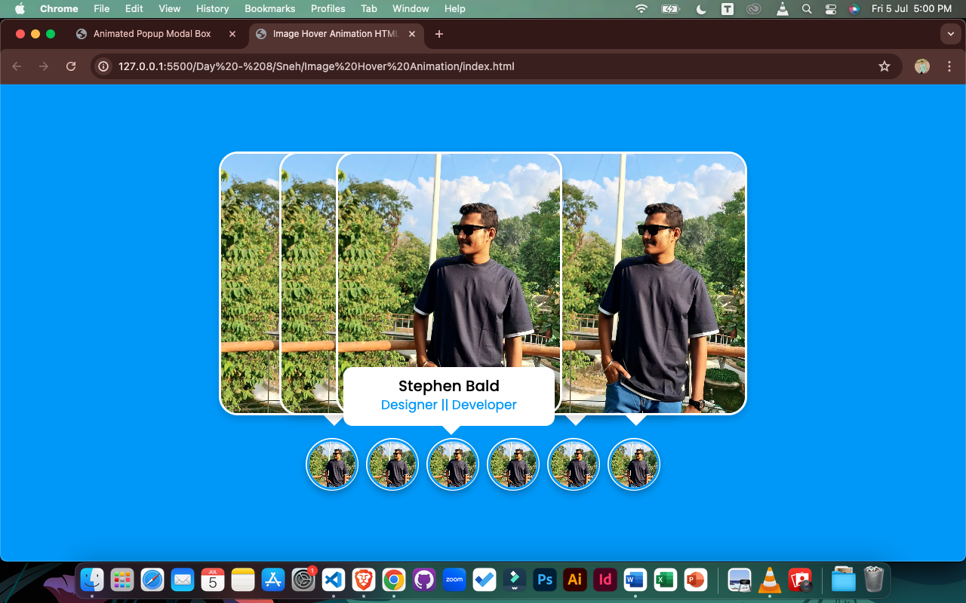

Program – 3 : Alert Box

HTML :

<!DOCTYPE html>

<html lang="en" dir="ltr">

<head>

<meta charset="UTF-8">

<title>Alert Box</title>

<link rel="stylesheet" href="style.css">

<link rel="stylesheet" href="https://cdnjs.cloudflare.com/ajax/libs/font-awesome/5.15.2/css/all.min.css"/>

</head>

<body>

<div class="container">

<input type="checkbox" id="check">

<label class="show_button" for="check">Click Me</label>

<div class="background"></div>

<div class="alert_box">

<div class="icon">

<i class="fas fa-exclamation"></i>

</div>

<header>Confirm</header>

<p>Are you sure want to permanently delete this Photo?</p>

<div class="btns">

<label for="check">Yes, Delete!</label>

<label for="check">Cancel</label>

</div>

</div>

</div>

</body>

</html>

CSS :

@import url('https://fonts.googleapis.com/css2?family=Poppins:wght@200;300;400;500;600;700&display=swap');

*{

margin: 0;

padding: 0;

box-sizing: border-box;

font-family: 'Poppins', sans-serif;

}

.alert_box,

.show_button{

position: absolute;

top: 50%;

left: 50%;

transform: translate(-50% , -50%);

}

.show_button{

height: 55px;

padding: 0 30px;

font-size: 20px;

font-weight: 400;

cursor: pointer;

outline: none;

border: none;

color: #fff;

line-height: 55px;

background: #2980b9;

border-radius: 5px;

transition: all 0.3s ease;

}

.show_button:hover{

background: #2573a7;

}

.background{

position: absolute;

height: 100%;

width: 100%;

top: 0;

left: 0;

background: rgba(0, 0, 0, 0.5);

opacity: 0;

pointer-events: none;

transition: all 0.3s ease;

}

.alert_box{

padding: 30px;

display: flex;

background: #fff;

flex-direction: column;

align-items: center;

text-align: center;

max-width: 450px;

width: 100%;

border-radius: 5px;

z-index: 5;

opacity: 0;

pointer-events: none;

transform: translate(-50% , -50%) scale(0.97);

transition: all 0.3s ease;

}

#check:checked ~ .alert_box{

opacity: 1;

pointer-events: auto;

transform: translate(-50% , -50%) scale(1);

}

#check:checked ~ .background{

opacity: 1;

pointer-events: auto;

}

#check{

display: none;

}

.alert_box .icon{

height: 100px;

width: 100px;

color: #f23b26;

border: 3px solid #f23b26;

border-radius: 50%;

line-height: 97px;

font-size: 50px;

}

.alert_box header{

font-size: 35px;

font-weight: 500;

margin: 10px 0;

}

.alert_box p{

font-size: 20px;

}

.alert_box .btns{

margin-top: 20px;

}

.btns label{

display: inline-flex;

height: 55px;

padding: 0 30px;

font-size: 20px;

font-weight: 400;

cursor: pointer;

line-height: 55px;

outline: none;

margin: 0 10px;

border: none;

color: #fff;

border-radius: 5px;

transition: all 0.3s ease;

}

.btns label:first-child{

background: #2980b9;

}

.btns label:first-child:hover{

background: #2573a7;

}

.btns label:last-child{

background: #f23b26;

}

.btns label:last-child:hover{

background: #d9210d;

}

Output :

